**Entity-Level Dimensional Data Model for Tracking Customer Revenue by Sales Territory and Time**

**Tables and Fields:**

1. **dim_customer** (Dimension Table for Customers)
   * **customer_key** (Primary Key): Unique identifier for each customer.
   * **customer_id**: Identifier for the customer, probably from an external source.
   * **customer_name**: Name of the customer, stored as a VARCHAR of length 100.
   * **territory_key**: Foreign key reference to the dim_territory table.
   * **create_date_key**: Foreign key reference to the dim_date table, marking the date of customer creation.
   * **effective_start_key** and **effective_end_key**: Foreign key references to the dim_date table, likely marking the start and end dates of a customer's effectiveness.
2. **dim_territory** (Dimension Table for Territories)
   * **territory_key** (Primary Key): Unique identifier for each territory.
   * **territory_id**: Identifier for the territory, likely from an external system.
   * **territory_name**: Name of the territory, stored as a VARCHAR of length 100.
   * **region**: Region of the territory, stored as a VARCHAR of length 100.
   * **create_dt**: Creation date for the territory record, stored as DATETIME.
   * **effective_start_key** and **effective_end_key**: Foreign key references to dim_date, marking the effective start and end dates for the territory.
3. **dim_date** (Date Dimension Table)
   * **date_key** (Primary Key): Unique identifier for each date.
   * **date_value**: Actual date, stored in DATE format.
   * **year, quarter, month, day, day_of_week, week_of_year**: Breakdown of date components for easier querying and reporting.
   * **is_weekend**: Boolean flag indicating if the date falls on a weekend.
4. **fact_revenue** (Fact Table for Revenue)
   * **revenue_key** (Primary Key): Unique identifier for each revenue record.
   * **revenue_id**: Identifier for revenue transactions, possibly from an external system.
   * **customer_key**: Foreign key reference to dim_customer, linking revenue to specific customers.
   * **amount**: Revenue amount, stored as DECIMAL with a precision of 15 and scale of 2.
   * **revenue_date_key**: Foreign key reference to dim_date, representing the date of revenue generation.

### **Relationships:**

* **dim_customer** is linked to **dim_territory** through the territory_key field, which establishes the relationship between customers and their respective territories.
* **dim_customer** also has multiple references to **dim_date** via create_date_key, effective_start_key, and effective_end_key, which capture various date-based information for customers.
* **dim_territory** is similarly linked to **dim_date** using effective_start_key and effective_end_key, denoting the valid time range of each territory.
* **fact_revenue** is the central fact table, connecting to **dim_customer** via customer_key and **dim_date** via revenue_date_key, allowing the analysis of revenue by customer and date.

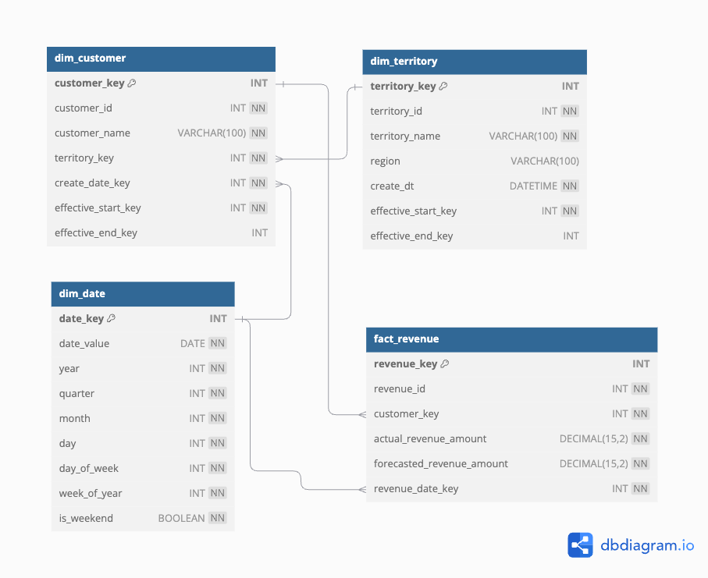

### 

### 

### 

### **Actual Revenue by Sales Territory**

### **Bar Chart**

* **X-Axis**: **Sales Territory** (e.g., Northeast, Mid-Market, Southwest)
* **Y-Axis**: **Total Actual Revenue** (aggregate revenue value)
* **Bars**: Each bar represents the **total revenue** for a specific **Sales Territory**
* **Color Coding (Optional)**: Different colors for each quarter to show trends within each territory over time.

### **Visualization Explanation**

* **Sales Territory**: Indicates the name of each sales region.
* **Quarter** and **Year**: Shows the specific time period for the revenue figures.
* **Total Actual Revenue**: Displays the sum of actual revenue for each territory per quarter, helping stakeholders compare performance across territories and time periods.

*Script to Calculate Total Actual Revenue by Sales Territory, Quarter, and Year*

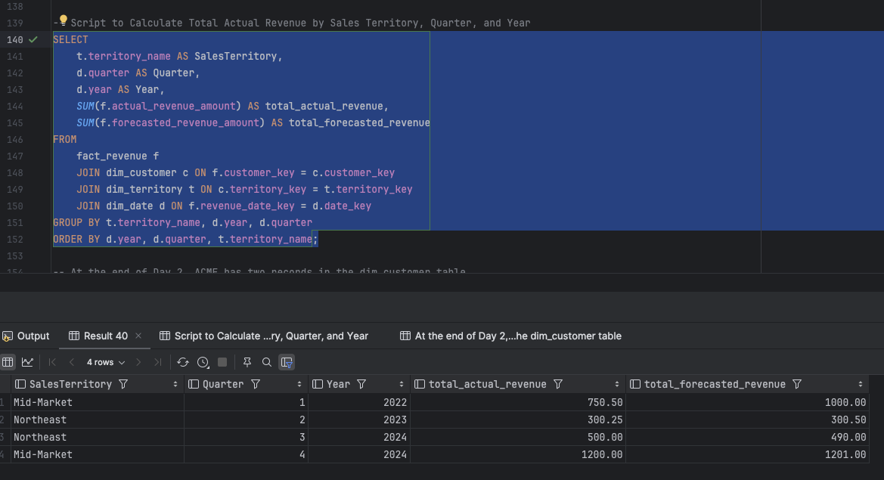

**At the end of Day 2, ACME has two records in the dim_customer table:**

1. One record shows ACME in the **Northeast** territory, effective from 2024-07-01 to 2024-10-01.
2. The second record shows ACME realigned to the **Mid-Market** territory, starting from 2024-10-01 with no effective_end_key, indicating it’s the current alignment.

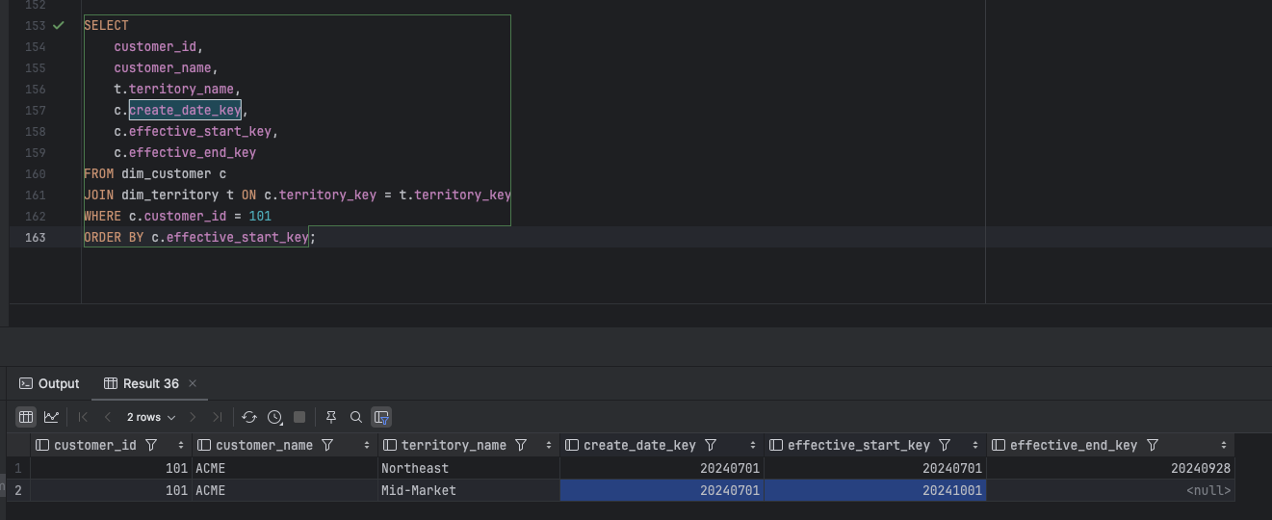

**Join Forecasted Revenue with Actuals**

The dim_customer table should use customer_id instead of customer_key as the unique identifier for joins. The join condition should be written as:

**ar.customer_id = c.customer_id AND ar.revenue_date_key BETWEEN c.effective_start_key AND COALESCE(c.effective_end_key, 30000101)**

This allows a view to be created that can be easily joined.

Alternatively, in this case, we can separate it into two tables: **revenue** and **forecasted** revenue.

**Count of Distinct Customers with Revenue > $10K:**

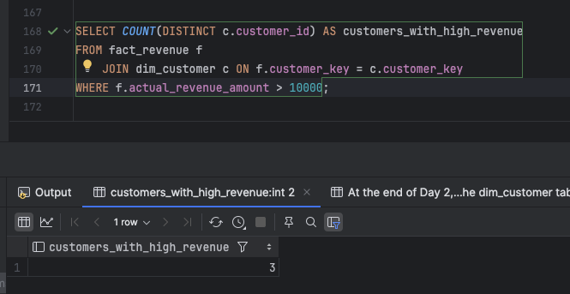

**Sum of Actual Revenue, Forecasted Revenue, and the Difference for Each by Quarter & Territory**

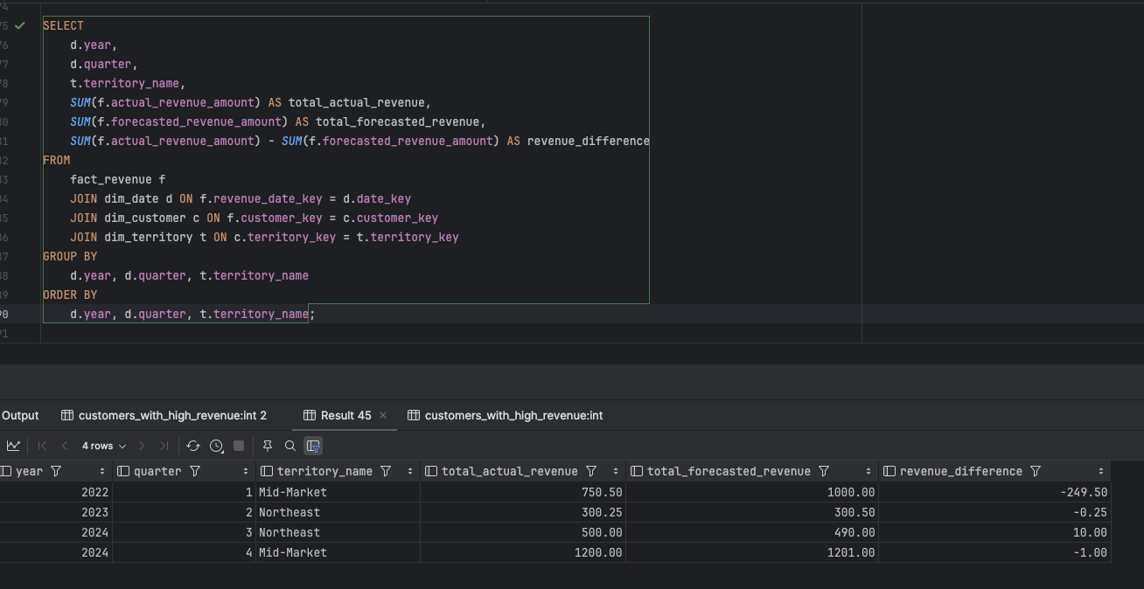

**Return Territories That No Longer Exist as of Today (But Did Exist Previously)**

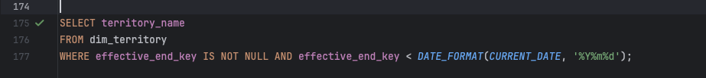

This script creates a data model with tables for date, territory, customer, and revenue, including sample data and a procedure to populate dates.

**Key queries:**

1. Calculate actual vs. forecasted revenue by customer, quarter, and territory.
2. Summarize revenue by territory and year.
3. Count customers with revenue > $10K.
4. Identify inactive territories.

These queries enable revenue analysis, customer performance tracking, and territory management insights.